**DAILY ONLINE ACTIVITIES SUMMARY**

|  |  |  |  |  |  |  |  |  |
| --- | --- | --- | --- | --- | --- | --- | --- | --- |
| **Date:** | **23/06/2020** | | | | | **Name:** | **VANDANA** | |
| **Sem & Sec** | **IV sem & B section** | | | | | **USN:** | **4AL18CS095** | |
| **Online Test Summary** | | | | | | | | |
| **Subject** | | **-** | | | | | | |
| **Max. Marks** | | **30** | | **Score** | | | **-** | |
| **Certification Course Summary** | | | | | | | | |
| **Course** | **Blockchain Basics** | | | | | | | |
| **Certificate Provider** | | | **Greatlearning academy** | | **Duration** | | | **2.5hours** |
| **Coding Challenges** | | | | | | | | |
| **Problem Statement1:** Write a C Program to Sort a stack using a temporary stack.  **Problem Statement2:** Python Program to Split the array and add the first part to the end There is a given an array and split it from a specified position, and move the first part of array add to the end. | | | | | | | | |
| **Status: Executed** | | | | | | | | |
| **Uploaded the report in Github** | | | | | **YES** | | | |
| **If yes Repository name** | | | | | **Online-coding** | | | |
| **Uploaded the report in slack** | | | | | **YES** | | | |

Online Test Summary: No internals conducted today.

Online Certification Course Summary: In today’s session I have learnt about blockchain solutions and how blockchain works what is the procedure and how the transactions are done between the people and how is it recorded and also about the security.

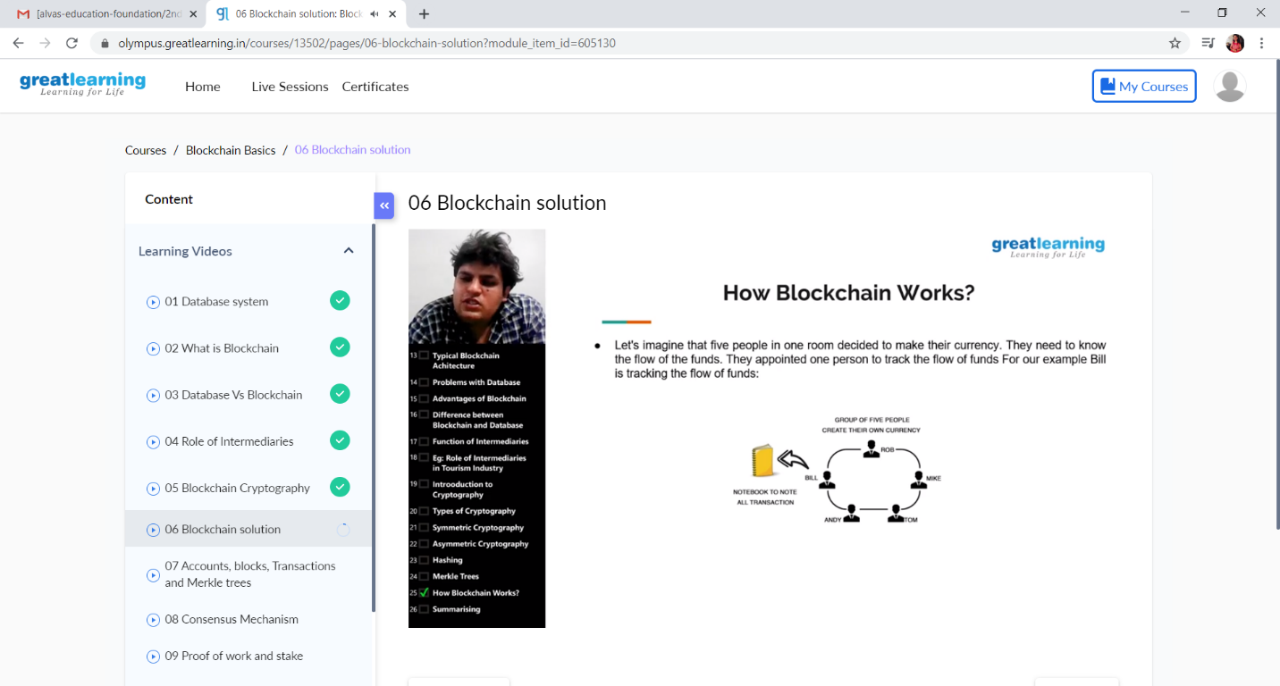

This is the snap shot of today’s session.

Online Coding Summary: **Today I had received one program from prof. Venkatesh CSE Dept. and prof. Vasudev CSE Dept. The program is mentioned above in the coding challenges(pg.01). I have also uploaded it to my Github repository.**

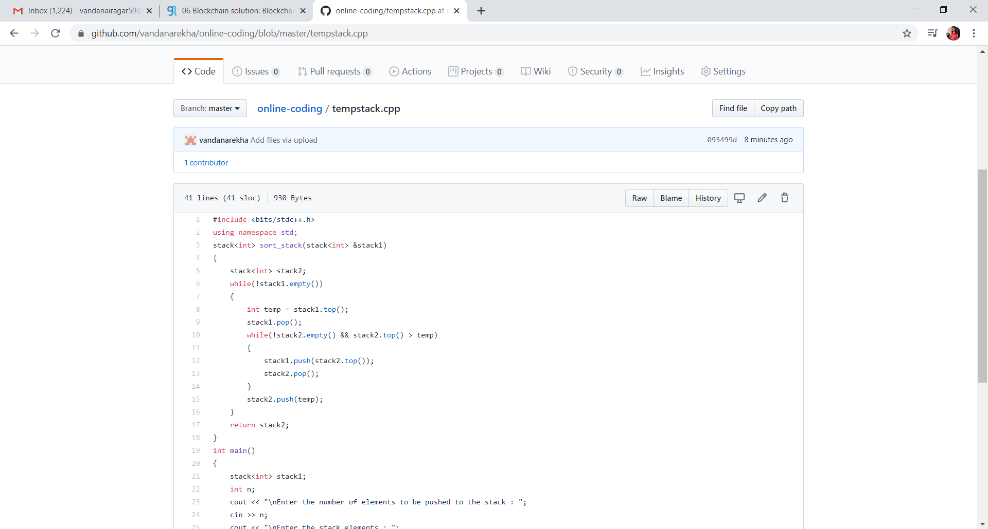

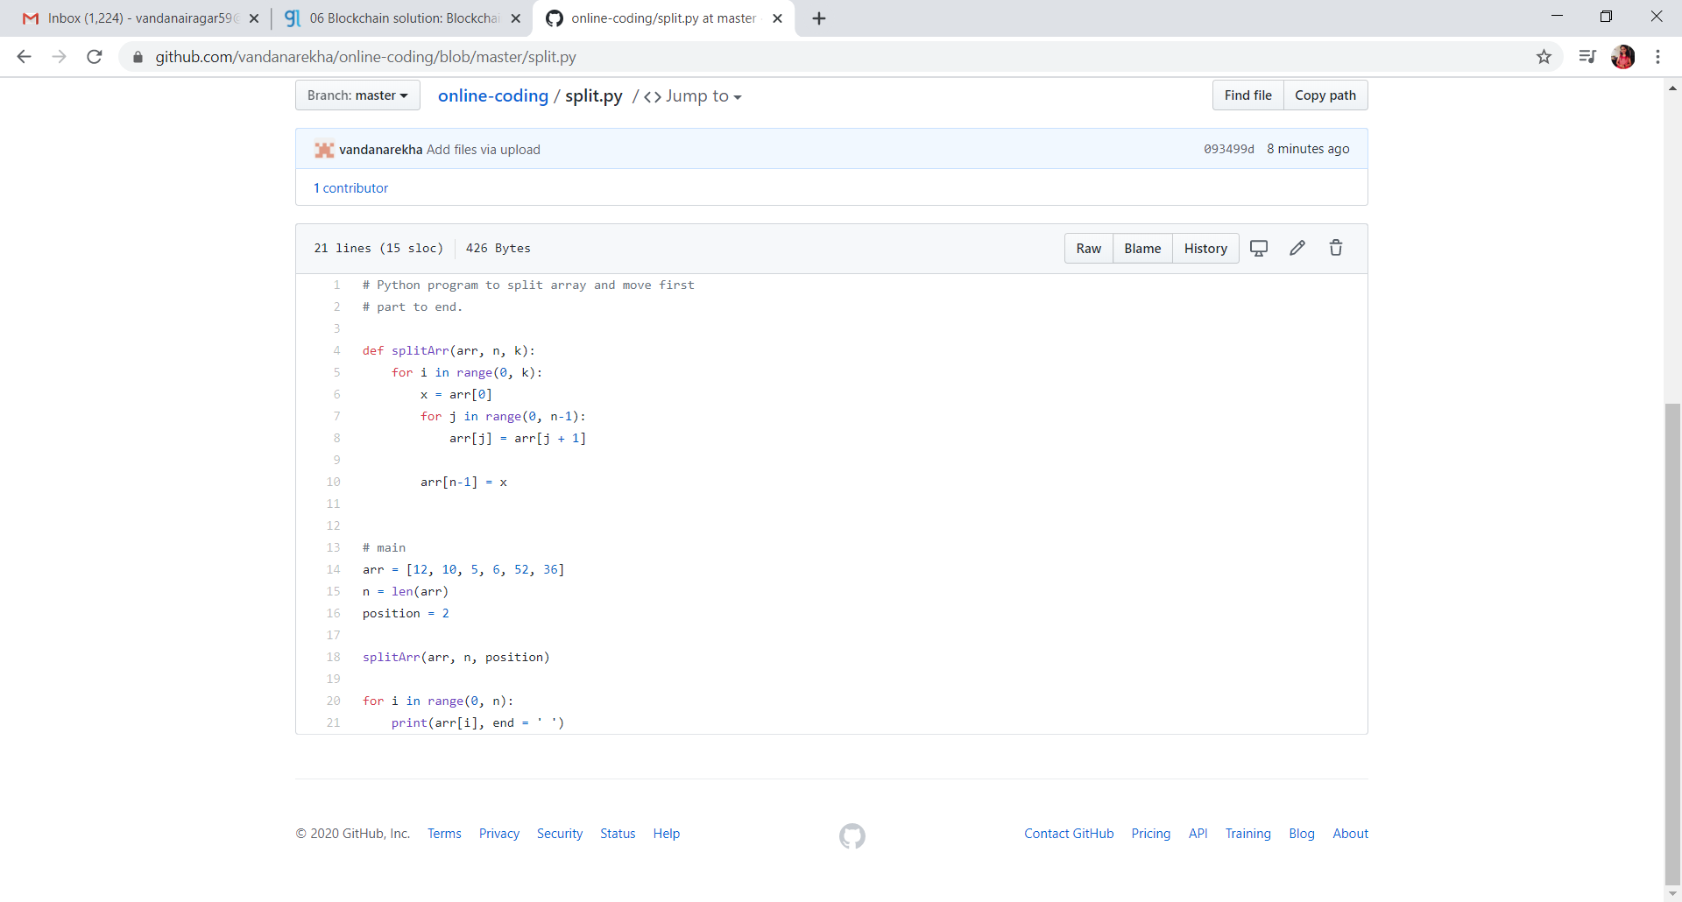

**This is the snap shot of my Github repository** were I have uploaded the code. File name tempstack.cpp and split.py

Webinar: Today I had attended the webinar organized by CSE Department AIET. The webinar was on Internet Of Things-Opportunities and Challenges done by Prof. Sushant M CSE Dept.